ASSIGNMENT 2:
Module 3: Control Structures in Python

Task 1: Check if a Number is Even or Odd
Problem Statement: Write a Python program that:
1. Takes an integer input from the user.
2. Checks whether the number is even or odd using an if-else statement.
3. Displays the result accordingly.
Expected Output:
The program should return an output like:
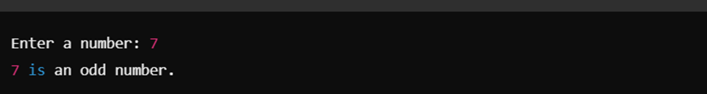
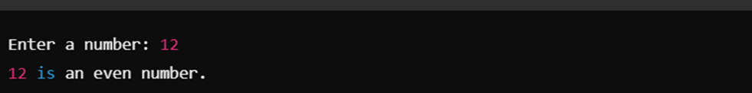

Task 2: Sum of Integers from 1 to 50 Using a Loop

Problem Statement: Write a Python program that:
1. Uses a for loop to iterate over numbers from 1 to 50.
2. Calculates the sum of all integers in this range.
3. Displays the final sum.

Expected Output:
The program should return:
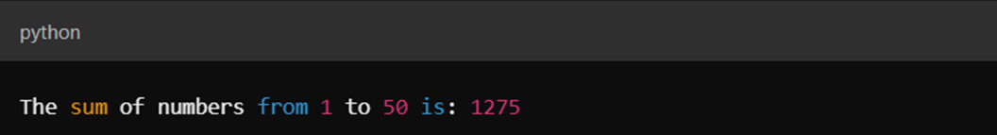

Submission Instructions:
- Create a GitHub repository and upload your Python scripts (.py files).
- Ensure the repository includes a README.md file that describes the functionality of your programs.
- Add both Task 1 and Task 2 scripts in the same repository.
- Submit the link to your GitHub repository once uploaded.

Reference:
Follow the Python course - Module 3: Control Structures in Python for additional guidelines and examples.

Note:
Please test your project thoroughly and check all the validations and error handling prior to ensure it works as expected before submission.
You can always connect to the mentor using the chat support option for any doubts or queries!

